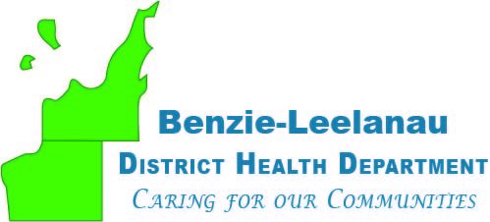
www.bldhd.org
Leelanau County Office
7401 E. Duck Lake Rd
Lake Leelanau, MI 49653

Phone: 231-256-0200
Fax: 231-256-7399

Benzie County Office
6051 Frankfort Hwy, Ste 100
Benzonia, MI 49616

Phone: 231-882-4409
Fax: 231-882-0143

FOOD SAFETY/SANITATION
MANAGEMENT CERTIFICATION CLASS

The Benzie-Leelanau District Health Department will be offering the National Registry of Food Safety course, "Food Safety Management Principles". The course covers principles necessary to maintain food safety and sanitation within your operation and prepares participants for the Food Safety Manager Certification Examination. The course will meet initial and refresher training requirements.

The cost of the class will be $115.00, which includes the course book and certification test. The one day class and exam are scheduled in Benzie County, at the Benzie County Health Department, Thursday, April 4th, 2024, 8:30 AM to 4:30 PM, (lunch on your own). Class will take place at 6051 Frankfort Hwy. Benzonia, MI 49616.
Please contact Nicholas Dow, at (231) 256-0216, as soon as possible to register and receive the course book for review, or if you have any questions.

-------------------------------------------------------------------------------------------------------------

REGISTRATION

Facility__________________________________________

Participant | Email | Phone Number

Total fee due___ X $115.00 (per individual) = ____________

Please make checks payable to Benzie-Leelanau District Health Department (BLDHD), and remit with registration to:

Environmental Health Division
Benzie-Leelanau District Health Department
7401 E. Duck Lake Rd.
Lake Leelanau, MI 49653

